Lenny Martinez, Mon PM

**Preliminary Results**

1. **Abstract**

The goal of my experiment is to calculate a ratio of the area of the sweet spot of a tennis racket to the overall area of the racket head. My method for investigating the area of the sweet spot racket (The unknown in this experiment) was to clamp the racket down to the table on the side of the handle so the head could vibrate freely. I then attached 4 accelerometers to the racket head and collected data by hitting specific spots on the racket with an impact hammer to excite the racket and get acceleration data. For preliminary data, I wanted to simply see if I could collect accurate acceleration data from the racket and compare the impulse responses. Although I don’t yet have a good model for the overall racket I can collect data and analyze each sample.

1. **Sketch of Setup**

The racket is clamped to a table by the grip side with two clamps and accelerometers are attached in the four cardinal directions as shown in Figure 1 with zip-ties. Figure 2 shows what this looked like at the time of collecting data.

**­**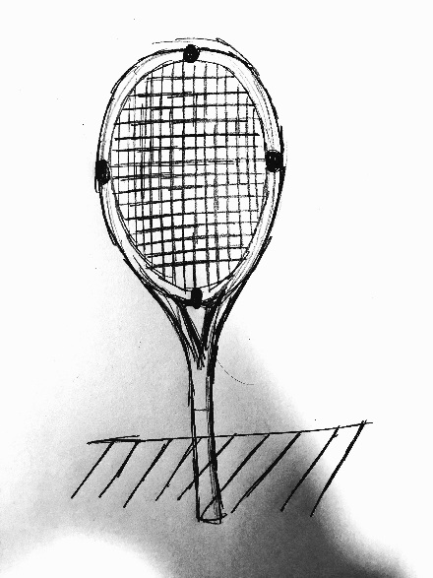

**Figure 1.** Sketch of Racket Setup for experiments. Tennis racket is clamped to a table on the side of the grip (clamp not pictured in sketch) and accelerometers are placed at each of the cardinal directions of the racket, along the planes of symmetry of the racket head.

After the setup, the racket was then struck with an impact hammer at different locations. For the preliminary results I only looked at the center of the racket and two points equidistant from the center, one above (towards the head of the racket) and one below (towards the grip and throat). These spots are marked on Figure 3.

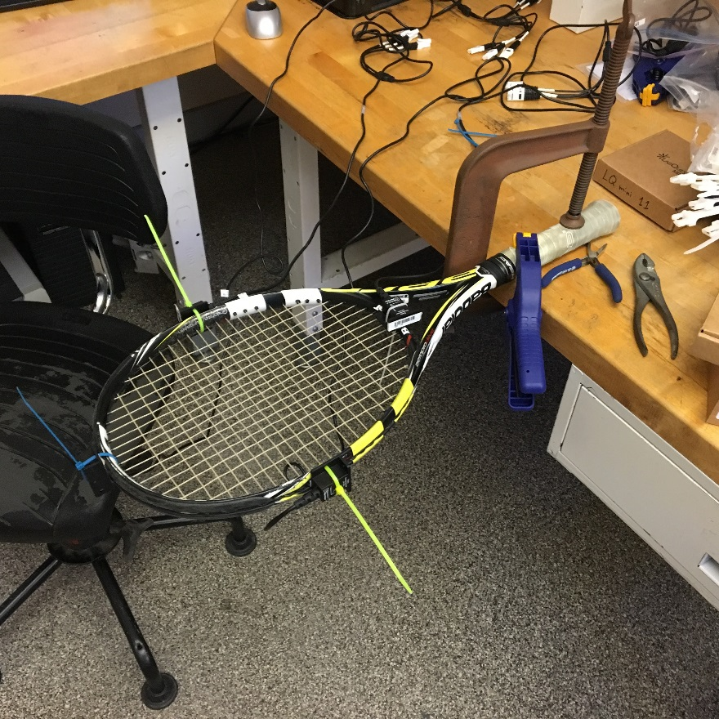

**Figure 2.** Photo of setup during initial data collection for Babolat AeroPro Drive racket. The racket was clamped down with two different clamps to make sure it was fully immobile on the end of the grip and 4 accelerometers were attached in the cardinal direction along the main planes of symmetry of the racket head.

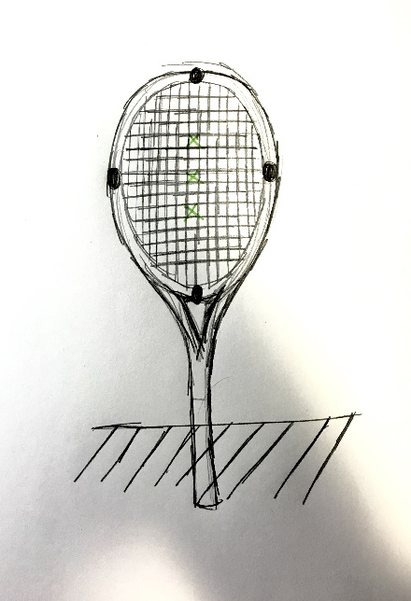

**Figure 3.** The points where vibrational data was collected from the racket is shown in this figure by the green x marks on the black and white setup sketch. The middle point is located at the center of the racket which was calculated using the number of strings in the longitudinal and latitudinal directions. Then the other two points were picked to be two square spaces above and below the center. Future analysis will include points higher and lower than these as well as looking into points to the left and right of the center.

1. **Data**

My goal for data is to create a map of each racket head quantifying vibration. But for preliminary results, I looked at the impulse response of each set of data. The code used for analyzing data was based on Lab 4 and modified mainly with the help of Dr. Hughey and Dr. Swithenbank.

**Location: Center**

When looking at the vibrations that occurred from striking the racket on the center of the string bed, the only accelerometer that produced a response was the one located by the bottom of the racket (near the throat). To better look at this data I found the force integral for each sample and then normalized the acceleration data by the force integral. This normalized the acceleration data, but was not a very good measure of which racket had a larger sweet. Figures 4 and 5 show that both rackets handle dissipation of energy in about the same way.

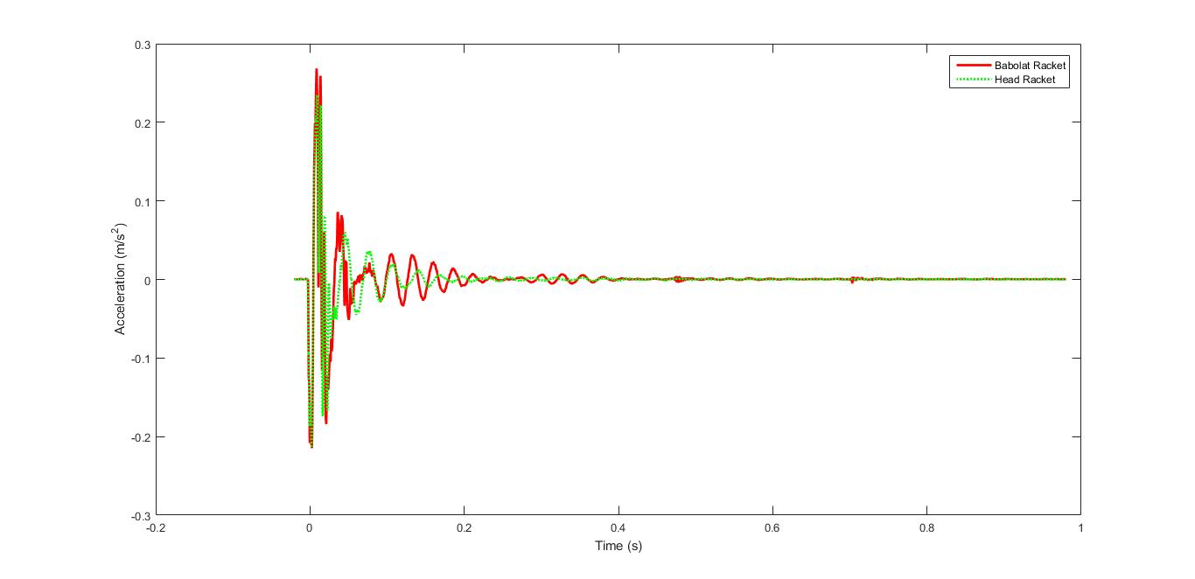

**Figure 4**. This is a graph of the time response of two different rackets being struck at the same point (their center). To account for the different force that may have been used, each set of points has been normalized by the integrated force around the impulse peak. This graph shows that for these two random samples of the same spot, the rackets dissipate force in the same manner.

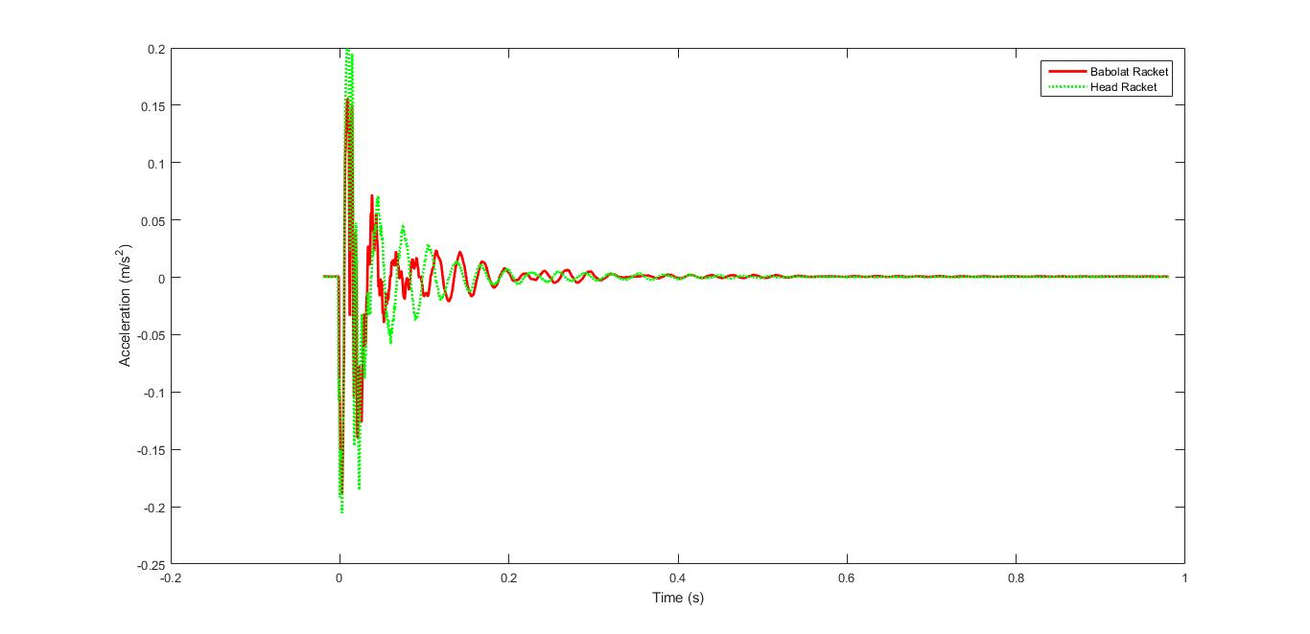

**Figure 5**. This is a graph of the time response of two a different pair of samples from the same two rackets as in Figure 4 being struck at the same point (their center). To account for the different force that may have been used, each set of points has been normalized by the integrated force around the impulse peak. This graph shows that for these two random samples of the same spot, the rackets dissipate force in the same manner.

**Location: Bottom #1**

For areas not in the center, we do have all accelerometers working so we can generate bode plots comparing the different accelerometers. It should be noted that the top and bottom as well as the left and right in pairs produced the same bode plots so there is overlap in the plots.

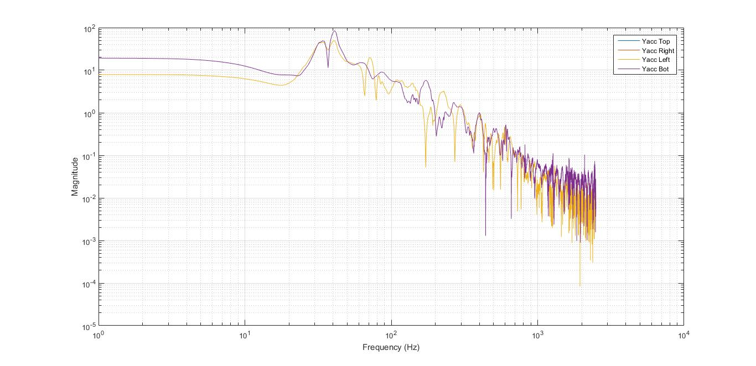

**Figure 6.** This is a graph of the magnitude half of a Bode plot for one of the samples from the Babolat racket when struck in the marked point below the center. It is important to note the overlap between the top and bottom accelerometers and also the left and right accelerometers. The impulse response of the system seems to have a peak at about 40 Hz.

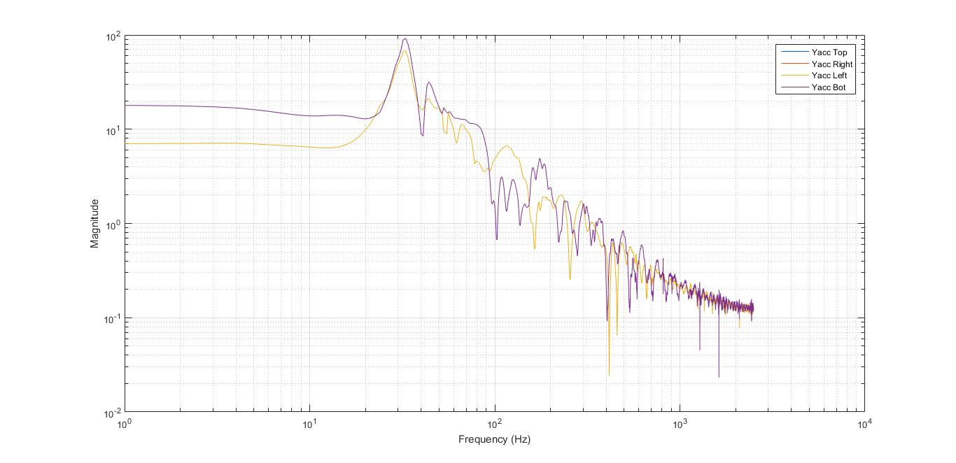

**Figure 7.** This is a graph of the magnitude half of a Bode plot for one of the samples from the Head racket when struck in the marked point below the center. It is important to note the overlap between the top and bottom accelerometers and also the left and right accelerometers. The impulse response of the system seems to have a peak at about 35 Hz.

When we compare the magnitude Bode plots for these samples we can see that the Babolat racket peaks at a later frequency than the Head racket when struck below the sweet spot. Also the magnitudes are on the same order (somewhere between 100 and 0.1) and that the Babolat racket experienced much more noise at higher frequencies than the Head racket.

**Location: Up #1**

Doing the same analysis as we did with the Bottom #1 location, we generate magnitude Bode plots using code written by Dr. Hughey and Dr. Swithenbank.

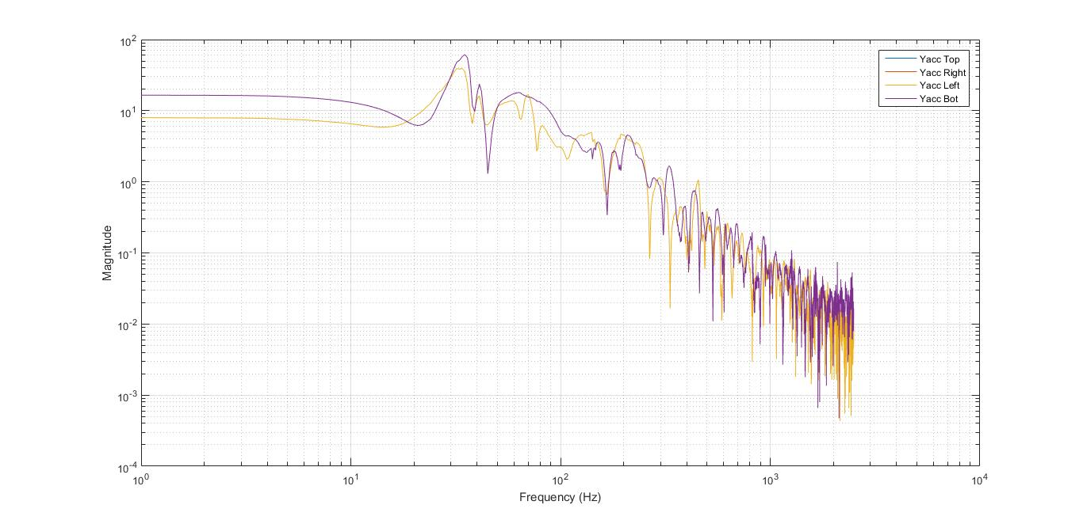

**Figure 8.** This is a graph of the magnitude half of a Bode plot for one of the samples from the Babolat racket when struck in the marked point above the center. It is important to note the 1:1 overlap between the top and bottom accelerometers and also the left and right accelerometers. The impulse response of the system seems to have a peak at about 25 Hz.



**Figure 7.** This is a graph of the magnitude half of a Bode plot for one of the samples from the Head racket when struck in the marked point above the center. It is important to note the overlap between the top and bottom accelerometers and also the left and right accelerometers. The impulse response of the system seems to have a peak at about 20 Hz.